 | Fakoli – A Programmer’s Introduction



Document Version | Date | Author(s) | Comments
0.1 | 4/13/2010 | Andy Green | Initial Draft
Table of Contents

1. Introduction 3
Fakoli Design Principles 3
Lightweight Design 3
Promoting a Rich Data Model 3
Promoting a Clear Programming Style 4
2. Data Model 5
Defining a Data Model object 5
Fields 5
Relationships 6
Class Constructor 6
Querying the Data Model 7
Instantiating from a Primary Key 7
Traversing Relationships 7
Simple Queries 8
Value Queries 8
Grouped and Indexed Queries 8
Regrouping and Reindexing Query Results 9
Inner Joins 9
Handling Cross-Reference Relationships in Inner Joins 10
3. Automated Web Forms 11
Field Renderers 12
Other Customization Options 13
Validation 14
Saving the Web Form 16
Loading Data into the Form 16
Search Forms 16
4. List Views 18
Data List View 18
Grouped Data View 19
Exporting Data Views to Excel 19
5. Content Management System 21

Introduction
Fakoli is a lightweight, entity-based framework designed to simplify development of web applications. The framework is open source (under the MIT License). Currently somewhat dissimilar versions exist for PHP and .NET. This document relates to the PHP version only.

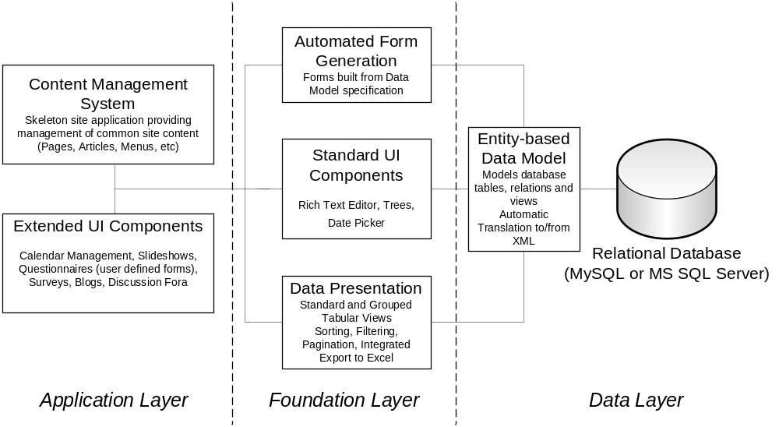
Figure 1 – Architecture of Fakoli

Fakoli Design Principles

The framework tries to adhere to the following principles

Lightweight Design

The framework has primarily been shaped by the philosophy of lightweight design. We believe that the less code and the fewer independent sub-systems there are in a software solution, the fewer the bugs, and the higher the quality. We also firmly believe that when a customer’s needs are not an exact match for an off-the-shelf application, there needs to be a way to implement a more targeted solution without either building from scratch or working with expensive, difficult to configure applications or application frameworks. Thus, Fakoli is conceived as a lightweight framework that will provide you with the basic common functionality required to build a web application. However, there are no complicated configuration files, or interpreted XML data mappings. Everything is in code with an emphasis on re-usability, maintainability and conciseness.

Promoting a Rich Data Model

Fakoli is an entity-based framework. Tables in the relational data store are modeled directly with classes in the application’s data model. Rows in the data store are then instantiated as objects (or entities) for manipulation by the application. The definition of these entities is handled in a declarative fashion, making the data model classes easy to write (or generate), easy to read, and directly executable (rather than having the structure defined in a configuration file that needs to be parsed with each access or held in shared memory by the application server). These data model objects provide a rich set of functionality that encapsulates the common operations required of them:

      - Querying from the relational data store
      - Persistence to the relational data store
      - Traversal of relationships within the data model
      - Serialization to XML and JSON, for network interoperability
      - Formatting for text manipulation and output

Promoting a Clear Programming Style

One of the key benefits of having an underlying rich data model for your application is that it reduces the semantic gap between the code you are writing and the requirements you are writing against. Using Fakoli, most of the minutiae of working with the database are handled for you. The code you write is in terms of the data model objects you have defined and the relationships between them, making the body of your PHP code much more readable and maintainable.

Fakoli is structured in such a way that if you follow best practices with your database design (meaningful field names, well-normalized data schema, etc.) then most of the drudge work of your day-to-day programming will simply disappear. For instance, if in the database you name a field “employee_salary” then this field name will be used in the data model object and further, Fakoli will automatically reformat the field name to “Employee Salary” when displaying in forms on your site. If, however, you named that field “s” you would need to explicitly set up field aliases for this field to have them display in a readable fashion. This is the key to Fakoli’s design philosophy – we try to make it easier to do the right thing.

Data Model
This is a mechanism for mapping tables in the database to objects in PHP, a technique that is generally known as Object Relational Mapping (ORM). These object definitions form the data model from which the web application can be built.
- Functions for querying the database and returning the results as collections of datamodel objects.
- Methods on the datamodel objects to support saving their data to and loading it from the database.

Defining a Data Model object
Data model objects are defined for a table by deriving a class from the DataItem base class. This class then specifies the field types to be used to represent each of the fields in the table. Fields are handled by the Automatic Form engine according to their type, so how you specify the field here controls how your application will look. Generally it is good practice to put the data model object in a file within the /datamodel/ folder of your application (for example the datamodel for a table named task would have the path /datamodel/task.inc).
The structure of a data model class definition is shown below.

Fields
In the $fields array, you list all the fields in the database table in the order you would like them to appear in a web form. For each field, you specify its type handler. The available types are as follows:
Type | Use for Database Types | AutoForm handles as
Number | INTEGER, NUMERIC, FLOAT, DECIMAL | Short text field
String | VARCHAR | Single line text field
Text | VARCHAR, TEXT | Multi-line text area
HTML | VARCHAR, TEXT | HTML editor
Currency | NUMERIC, DECIMAL | Short numeric text field with 2 decimal places
Boolean | INTEGER, TINYINT | Checkbox
Password | VARCHAR | Password & Confirmation field – encrypted in database
Date | DATE | Text field with date picker
Timestamp | TIMESTAMP | No field, automatically updates with latest modification date and time
Table 1.1
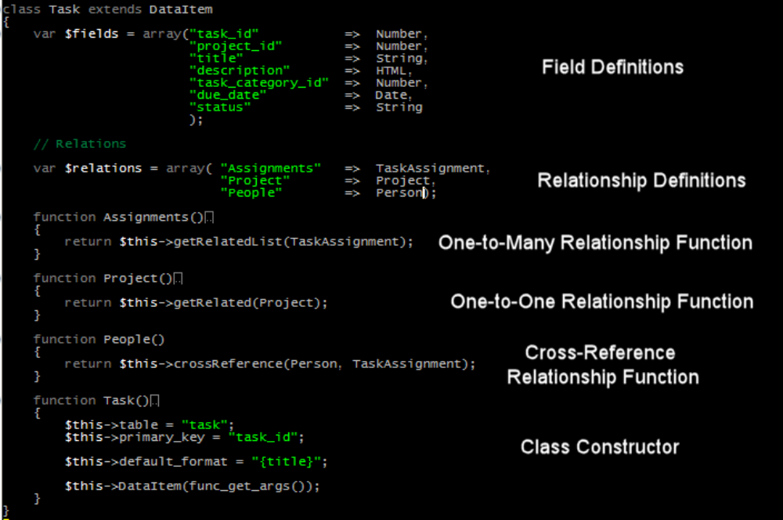
Example Data Model object

Relationships
The $relations array contains a mapping of function names to classes. Each of these relationships is then defined with a function. For instance, in the above example the Project() function returns the related Project object for a given Task. All the relationship functions are defined using the patterns above, corresponding to the structure in the database.

The DataItem base class provides three methods for implementing relationships:
- DataItem::getRelated() is used for one-to-one relationships, where the related class’ primary key is a foreign key in the source class.
- DataItem::getRelatedList() is used for one-to-many relationships, where the related class has a foreign key that maps to the source class’ primary key.
- DataItem::crossReference() is used for many-to-many relationships via a third cross-referencing class that contains foreign keys to both source and destination class primary keys.

Class Constructor
The class constructor is a function with the same name as the enclosing class (i.e. Task() in the example above). The definition of the class constructor for a data model object always follows the format shown above. It needs to define:
- The $this->table field, which specifies the table in the database that the class is mapping to
- The $this->primary_key field, which is the name of the primary key for the table, as defined in the database
- Optionally, the $this->default_format field can be used to specify how the object should be formatted by default. It should be a string with some field names in parentheses within it, according to the format you wish to follow. This is not used extensively within the framework at this point, and can be safely omitted if desired.
- Also, optionally the $this->pretty_class_name field can be used to provide a human readable name for the class (by default Fakoli will attempt to prettify the PHP class name to make it human readable – sometimes this does not have the intended results).
- Finally the $this->DataItem(func_get_args()) line is vital – it passes all the parameters passed into this constructor down to the base class constructor, which knows how to handle them.

Querying the Data Model

Once you have defined your data model classes, you can use them to query the database in a number of ways.

Instantiating from a Primary Key
The simplest way to retrieve a single object from the database is to instantiate it from its primary key. For instance, the following code snippet reads the task_id parameter from the HTTP query string, instantiates the corresponding Task object from the database and then outputs the contents of the title field.

$task_id = checkNumeric($_GET[‘task_id’]);
$task = new Task($task_id);
echo $task->title;

(Note the use of the checkNumeric() helper function – this function checks the value passed to it to ensure that it is either numeric or an empty string. Use this function whenever you read numeric values (such as primary keys) from the HTTP query string, to protect against SQL injection and cross-site scripting attacks.)

Traversing Relationships
We can use the relationships we defined in our data model class to traverse to related objects. For instance, following on from the example above we could use the following code to output the project title and a list of assigned people for our Task.

$project = $task->Project();
$people = $task->People(“ORDER BY last_name, first_name”);

echo “{$project->title}:\n“;
foreach($people as $person)
{
echo “{$person->first_name} {$person->last_name}\n”;
}

Note that in the call to the Task::People() relationship function we provided an extra constraint to order the related items.

Simple Queries
Querying the database for a list of results is handled via the query() function:

$tasks = query(Task, “WHERE due_date < now() AND status=’Pending’ ”);
echo “These are the tasks that are overdue:\n”;
echo formatItems($tasks, “{title}”, “\n“);
In the above example we also used the formatItems() function, which can be a useful way to generate output from the lists of objects returned by the query() functions.

When you call the query() function you specify the class of object that you are querying, and can then provide any SQL constraints (such as WHERE and/or ORDER BY clauses) that you wish to apply to the query. The results are returned to you as an array of objects of the specified class.

Value Queries
Sometimes you just need to retrieve aggregated values from the database. For this purpose you can use the queryValue() function:

$numOverdue = queryValue(Task, “COUNT(1)”, “WHERE due_date < now() AND status=’Pending’ “);
echo “There are $numOverdue tasks.”;

Grouped and Indexed Queries
One sophisticated feature that the framework provides is the ability to return query results in a structured format indexed by the values of a specific key. This can be especially useful when dealing with hierarchical data operations (such as populating a tree control), and can often be used instead of a join operation to simplify the application code without too much of an increase in database overhead.

The two functions provided to support these structured queries are called indexedQuery() and groupedQuery().

groupedQuery() is the more general of the two functions. It returns an array of arrays of DataItem objects of the specified class grouped by the value of the organizing field. This is best explained with a code example. The following code snippet displays all tasks listed by project. The projects are listed in alphabetical order, the grouped tasks are listed in order of their due date.

$projects = query(Project, “ORDER BY title”);
$tasks = groupedQuery(“Tasks, “ORDER BY due_date”, “project_id”);

foreach($projects as $project)
{
if ($tasks[$project->project_id])
{
echo “<h1>{$project->title}</h1>”;
$projectTasks = $tasks[$project->project_id];

echo “<ul>”;
foreach($projectTasks as $task)
{
echo “<li>{$task->title}</li>”;
}
echo “</ul>”;
}
}

indexedQuery() can be used when you are sure that the values being returned in the organizing field are going to be unique. Rather than returning an array of arrays, it returns an array of objects (so each unique key value has one object). indexedQuery() calls are especially useful for providing lookup tables for the existence of objects based on their unique primary keys.

Regrouping and Reindexing Query Results
Sometimes you will have already queried data from the database and then find that you also need to have it in a grouped or indexed format. Rather than make another query for the same data, you can use the provided functions regroupList() and reindexList() to achieve this. For instance, the following code retrieves the full list of tasks, then regroups them by project:

$tasks = query(Task, “ORDER BY due_date”);
$tasksByProject = regroupList($tasks, “project_id”);

These tasks can be applied to structured results as easily as to ordinary lists. For instance, the following code initially queries tasks by project, then regroups them by category.

$tasksByProject = groupedQuery(Task, “ORDER BY due_date”, “project_id”);
$tasksByCategory = regroupList($tasksByProject, “task_category_id”);

Inner Joins
Through the use of relationships and structured queries you can often avoid having to explicitly use database joins within your code. Generally this is good practice – although joins are a powerful SQL feature they can quickly lead to complexity in application logic that deals with their results.

In some situations, however, joins are inevitable and, indeed desirable. One example of this might be for implementing advanced search features, where the queries that are generated might pull in any combination of a number of tables, and the structure of the query is thus determined by the user’s input parameters. To help simplify handling these cases, the framework provides the InnerJoin class.

The InnerJoin class provides a simple interface for building joins. For instance, the code below creates an inner join between the Task, and Project classes.

require_once “framework/join.inc”;

$join = new InnerJoin();
$join->add(Task);
$join->add(Project);

$joinResults = $join->query(“WHERE due_date < now() AND status=’Pending’ ”);

To build the join, you instantiate a new InnerJoin object, then call the add() method to add each of the DataItem classes that you wish to include in the join. You can then query the join via the query() method, passing in any constraints. There are also groupedQuery() and indexedQuery() methods available to return structured join results in much the same fashion as described in the Grouped and Indexed Queries section above.

The InnerJoin query methods return arrays of InnerJoinResults, rather than DataItem-derived classes. The InnerJoinResult class is simply an empty container that is filled with a field corresponding to each joined class. For instance, to continue our example above:

foreach($joinResults as $result)
{
$task = $result->Task;
$project = $result->Project;

echo “{$project->title}: {$task->title}\n”;
}

Additionally, there is a helper function called extractJoinResults() to help with extracting the results for just one of the classes in the join. Due to the way joins operate, there could be many duplicate rows, so a helper function is also supplied, called removeDuplicates() that removes duplicate entries from a list of DataItems.

$tasks = extractJoinResults(Task, $joinResults);
$distinctTasks = removeDuplicates($tasks);

Handling Cross-Reference Relationships in Inner Joins
When you are dealing with a many-to-many relationship (implemented by some kind of cross-reference table), you need to add the cross reference table to the join using the xref() method, rather than the add() method. See the below example, which builds a join from tasks to people, using the cross referencing table modeled by TaskAssignment.

$join = new InnerJoin();
$join->add(Task);
$join->add(Person);
$join->xref(TaskAssignment);

$joinResults = $join->query(“WHERE due_date < now() AND status=’Pending’ ”);

With the xref() method, the fields from the cross referencing table are not included in the join results.

Automated Web Forms
The AutoForm class enables you to build a web form page using a datamodel object. AutoForm renders each of the datamodel fields according to its type, validates the data entry, and saves the data back to the database. The example below shows how a web form can be constructed:

$task_id = checkNumeric($_GET[‘task_id’]);
$task = new Task($task_id);
$form = new AutoForm($task);

$script .= $form->writeScript();
$form->drawForm();

This example will display a web form as follows:

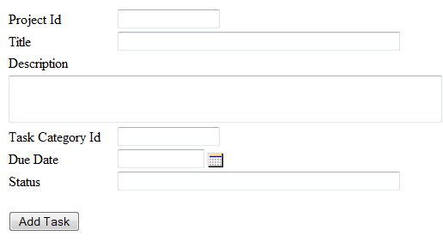
Figure 3.1

Handling the submission of the form is also a simple task for your code. With the AutoForm working in its default mode as shown above, we would simply expand out the code sample above as follows:

$task_id = checkNumeric($_GET[‘task_id’]);
$task = new Task($task_id);
$form = new AutoForm($task);

if ($method == “POST”)
{
if ($form->save())
{
redirect(“success.php”);
}
}

$script .= $form->writeScript();
$form->drawForm();
The save() method on the AutoForm object handles all the work of persisting the updated object to the database, and returns true if there were no errors. If an error occurred (such as a server-side validation exception on the form data) then this error gets displayed as part of the form output for display to the user. We will discuss the AutoForm’s validation features below.

This form gets us 80% of the way to a finished project. For the final 20%, we will employ AutoForm
customization options.

Field Renderers

Fakoli field renderers provide handling of the datamodel’s data types. Some field renderers, such as the DateFieldRenderer and the PasswordFieldRenderer are called by default when the datamodel specifies a field as being of type “Date” or “Password”, respectively. A list of these field renderers is shown in Table 1.1. Other field renderers, such as the SelectFieldRenderer, which renders a list in a drop down, can be set in the calling script to override the default. Fakoli provides the following additional field renderers:

Field Renderer | Use for Database Types | AutoForm handles as
Checklist | VARCHAR, TEXT | Checklist of options (an array) defined in the script or an included file, such as the datamodel. The user can select more than one. Data is stored as comma delimited text.
Cross Reference Select | VARCHAR, TEXT | Checklist of options retrieved from a specified table. The user can select more than one. Data is stored as comma delimited text.
File Upload | VARCHAR, TEXT | Input field with Browse button. The user can input a path or browse for the file.
Radio Button | INTEGER, TINYINT, VARCHAR | Radio button list of options of which the user can select at most one.
Rating | INTEGER, TINYINT, VARCHAR | Horizontally-aligned radio buttons with starting and ending labels to indicate low and high. User can select one.
Related Image Select | VARCHAR, TEXT | Drop down list of images retrieved from a specified table.
Related Item Radio Button | INTEGER, TINYINT | Radio button list of options retrieved from a specified table.
Related Item Select | INTEGER, TINYINT | Drop down list of options retrieved from a specified table.
Select | INTEGER, TINYINT, VARCHAR | Drop down list of options provided to the renderer; an array declared in the calling script or include file.
Select View Source | INTEGER, TINYINT, VARCHAR | Drop down list of options provided to the renderer with a button to the right of the drop down that enables the user to view the selected item through a popup window.
Tree Select | INTEGER, TINYINT | Tree control of options provided by the calling script. The tree can be set to single or multiselect.

In Figure 3.1, project_id is rendered as a numeric input field but we would prefer to display a drop down listing the existing project names retrieved from the database. AutoForm enables customization of the form with several alternative field renderers. For the project_id field, we will set the form to render the project_id field using the RelatedItemSelectFieldRenderer as follows:

$projectRenderer = new RelatedItemSelectFieldRenderer($form, “project_id”, “Project”, Project, “ORDER BY project_name”, “project_name”, “project_id”);

The above statement sets the form to render the field project_id with the project name fields retrieved from the Project datamodel object, ordered by the name field. The revised form display is shown in Figure 3.2.

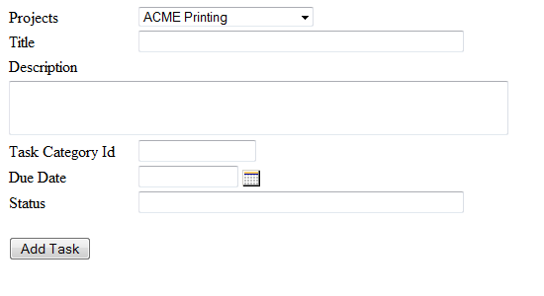
Figure 3.2

Other Customization Options

In addition to these optional Field Renderers, Fakoli’s AutoForm class provides a set of variables for customizing a web form. A few of the most commonly-used features are described below:

- allowDelete: whether the record shown in the form can be deleted.
- overrides: array of field labels to override the default.
- hidden: array of fields to be hidden from the user.
- readonly: array of fields that are not editable.
- onSaveComplete: script-defined callback function to be called after the record is saved.
- onDelete: script-defined callback function to be called after the record is deleted.
- submitLabel: “Save” button label to override the default.
- annotate: displays instructions or other information associated with a field

Suppose in our Task example, we wish to make the following changes:
- label the “Due Date” field as “Project Due Date”
- hide the “Status” field
- change the submit label to “Save”
- change “description” field from a text field to an HTML editor

We would add the following lines of code to our call script:

$form->alias(“due_date”, “Project Due Date”);
$form->hide(“status”);
$form->submitLabel = “Save”;
echo $form->writeScript();

The call to “writeScript()” above outputs any javascript needed for the display of the form and its fields. This script could also be output from a template file that also handles including javascript and css files and any modules you wish to include on your page.

To render the description field as an HTML editor, we change the fields array in the task datamodel as follows:
"description" => HTML,

The result is shown below:
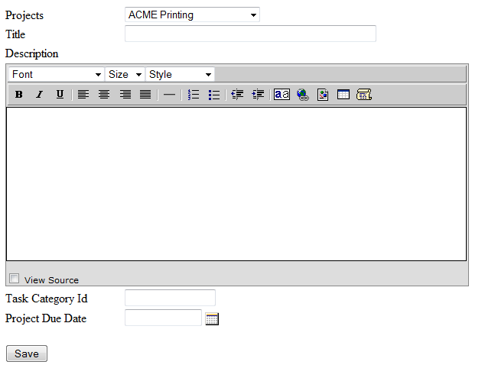

Validation

The AutoForm class also handles field validation prior to saving. The most common type of validation is whether a field is required, meaning the user enter a value. If in the above example, we wanted to make the fields “project_id” and “title” required, we would specify the following in the calling script:
$form->required(“project_id”, “title);

The resulting web form is shown below:
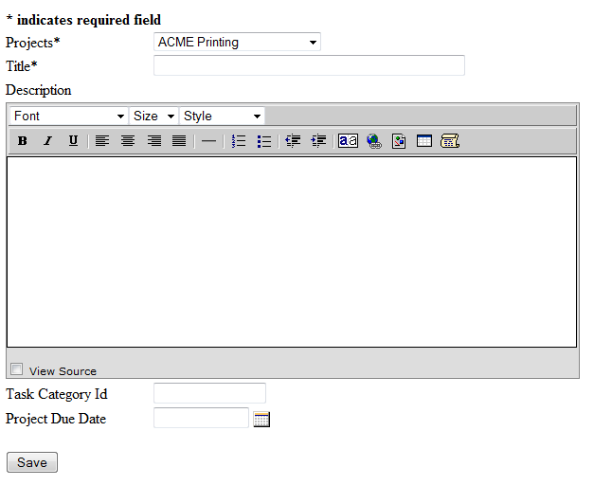

If the user clicks Save without entering a value in either required field, a popup message is displayed and the form will not save:

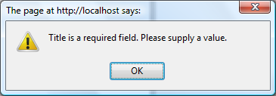

Some fields require most customized types of validation. The following additional validators can be added to a form:
- DateValidator: checks if the date is in the correct format
- TimeValidator: checks if the time field’s hours and minutes are within the numeric valid range
- UniqueValidator: checks all database values for a specified field to determine if the value entered in the web form is unique (useful for usernames or email addresses)
- MultiFieldUniqueValidator: checks whether a set of fields is unique within the database
- MatchValidator: checks whether two fields have matching values (useful for password verification)
- RegularExpressionValidator: checks whether a field’s value matches the supplied regular expression
- RangeValidator: checks whether a numeric value falls within a specified range

The following example adds the RangeValidator to the “age” field of a web form and specifies that the field label is “Age” and that the minimum age is 18 and maximum age is 60:

$form->validator->add(new RangeValidator(“age”, Age, 18, 60));

Saving the Web Form

The code we’re written so far displays the form properly but we need to add a few more lines to call AutoForm’s save function. The following code specifies that we want to save using “POST” and if save is successful, redirect to the task list page. This code should appear just above the call to writeScript().

if ($method == "POST")
{
if ($form->save())
{
redirect("task_list.php");
}
}

Loading Data into the Form

Data that we have saved to the database must also be retrievable into the form. The task_list.php would list all the tasks with a link to the task_form.php, sending the task_id to the page which might be done with an HTML “a” tag as follows:

<a href=”task_form.php?task_id={$task->task_id}”>{$task->title}</a>

When the user clicks on a link, the task form must retrieve the data from the existing task record. To do this, we add call the DataItem “load” function to load the task_id passed into the script:

$task_id = checkNumeric($_GET['task_id']);
$task = new Task();

if($task_id)
$task->load($task_id);

Search Forms

The Fakoli SearchForm class extends AutoForm to provide a web form for database searches. The task datamodel can be rendered as a SearchForm where the input fields represent search values rather than data values.
Using our task example, the following code would create a Search Form to search the database for a specified project and/or title:

$task = new Task();
$task->filter = new InclusionFilter("project_id", "title");

$form = new SearchForm($task, "GET", "task_results.php");
$form->params->fromGET();

$form->setMatchingMode("startsWith", "title");

$projRenderer = new RelatedItemSelectFieldRenderer($form, "project_id",
"Projects", Project, "ORDER BY project_name",
"project_name", "project_id");

echo $form->writeScript();
$form->drawForm();

The SearchForm parameters specify that the form should render the fields in $task and provide the results to the script “task_results.php” using “GET”. The setMatchingMode function specifies one of the following types of matches:
- equal – requires an exact match; default matching mode for numeric fields
- like – matches must contain the search string; default matching mode for string fields
- startsWith – matches must start with the search string
- from – the lower end of a range match
- to – the upper end of a range match

The resulting web form is shown below:

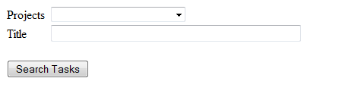
The SearchForm class calls the renderSearchField() function of the FieldRenderer class for each of the fields included in the form. The renderSearchField function creates the HTML for the search field, specifying the desired matching mode. If we wished to search for all “ACME Printing” projects that start with the letter “D,” we would enter the following values into the search form and click Search Tasks.

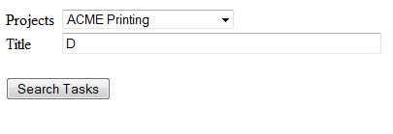

The results of the search would be shown on the “task_results.php” list page which could display results in table format using the ListView class, described in the following section.

List Views
The Fakoli List View classes provide display handling of a set of records in table list format or grouped into an expandable tree control.

Data List View
The Data List View displays a set of records in table format with sortable and filterable columns that can be set to display a set number or records per page. The following script creates a data list view of the task table:

$tasks = query(Task, "ORDER BY title");
$table = new DataListView($tasks, "tasks", "list", true, 10, true);
$table->column("Task Title", "<a href=\"task_form.php?task_id={task_id}\">{title}</a>", true);
$table->column("Project", "{Project.project_name}", true);
$table->column("Due Date", "{due_date}", true);
$table->cssStyle = "width: 70%;";

require_once "head.inc"; // header, styles, javascript, mootools
echo $table->writeScript();
$table->drawView();

The code above retrieves all the task records, creates a DataListView of those records, and turns on sorting and filtering. The script creates a table with 3 columns: title, project name, and due date. The script creates the table shown below:
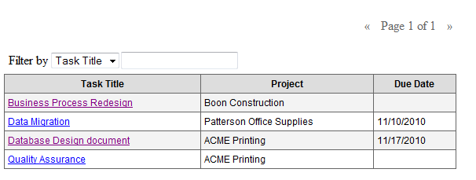
The data is initially sorted by the task title since that was the order of the query. If the user clicks on the “Project” column heading, the data will be sorted by project name, as follows:

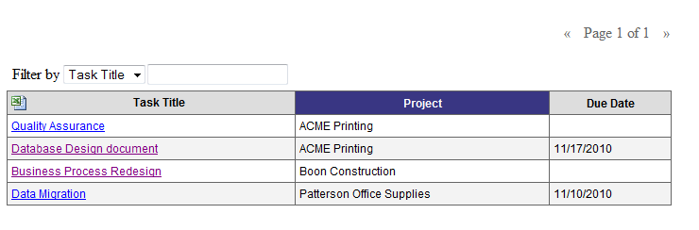

The data for column values can be derived from any of the fields in the set of retrieved records, any field that can be retrieved through a relation or function defined in the datamodel, or through a callback function. The following table describes the notation for each retrieval type. Note that the first three are passed to the column function as a string whereas the callback is not.

Type | Notation | Example
Field within the retrieved record | “{field}” | {title}
Field in a related table, defined in the datamodel | “{Relation.field}” | {Project.project_name}
Function defined in the datamodel | “{functionName()}” | {GetProjectName()}
callback function | functionName | getStatus where getStatus is a function defined in the calling script or one of its include files.

Grouped Data View

The Grouped Data View displays sets of records grouped by a specified field. If we wanted to display tasks grouped by their project, we would create a Grouped Data View as follows:
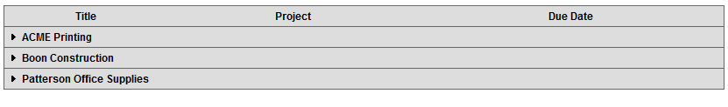
The following view shows the Grouped Data View with one node expanded:
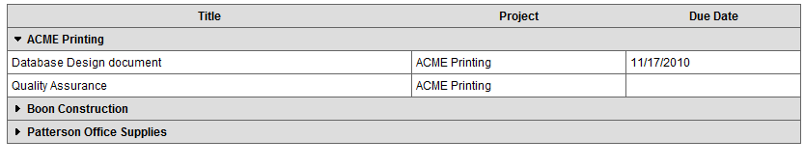

Exporting Data Views to Excel

Both the Data List View and Grouped Data List View classes can be exported to an Excel spreadsheet. The following code sets the Data List View table to exportable:

$table->excelFile = "tasks.xls";

The Excel icon is displayed on the top left of the table, as shown below:
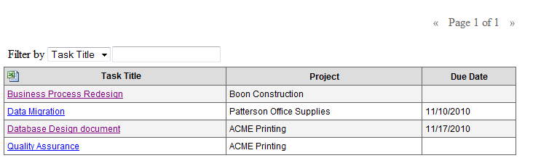
When the Excel icon is clicked, the user can choose to open or save the data to a specified file name.

Content Management System

